

CSC 424

February 2018

Sprint Plan for:

hExSCAPE:

Initialization

From Down2 Developers:

Christopher Touchette

Michael Ouille

Gabriel Mayo

Billy Loveday

Dane Reggia



**Sprint Goals and Dates**

Early goals for this sprint included getting Slack, GitHub, and Trello set-up. Each team member committed to learning as much C# and Unity as their schedule allowed before the end of this Sprint. Some team members are already well-versed in both environments which led to a variety of different commitments depending on level of prior familiarity. The biggest story being attacked in this sprint is gameboard creation. The completion goal for all of these stories is before the start of class on 3/5/18.

**Product Backlog**

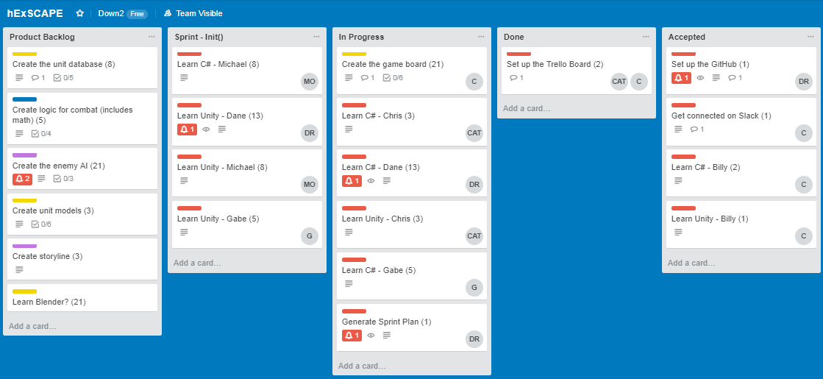

**Release Burndown Chart**

This burndown was created after some elaboration of initial stories. That is why the story point total has increased over the release plan total.

**Calculated Velocity**

Based on what has been allocated to the first sprint, the team is attempting to complete 75 story points, which is over half of the total. This may at first appear ambitious, but since the first week is reserved for mastering the critical knowledge, getting it out of the way can only serve to open the gateway for productive weeks to follow.

**Team Capacity Calculation**

The team neglected to officially declare the exact hour commitments for Sprint 1, but this has been noted as an opportunity for improvement in the next Sprint. For the purposes of Sprint 1, we will assume that the baseline commitment for each individual aligns directly with the team commitment of 10 hours. The team members will have a better feel for how much time they spent working during Sprint 1 and how much more or less time they will require in subsequent Sprints.

**Team Commitment**

Each team member will commit to an average of 10 hours per week on the development of the project. For the first sprint, since some members are already well-versed in the environments being used, some commitments are understandably lighter. We have committed to the Monday meetings during class time as well as an additional in-person meeting on Wednesday evenings that all members are expected to attend.

**Communication and Logistics Plan**

Outside of in-person meetings, the plan to communicate progress is to use the Slack chat to hold a “stand-up” meeting every evening between 8 and 10 pm. During that time window, each person will log in and write a sentence or two about what they have accomplished, any roadblocks, and what they will accomplish the next day. The Slack account can be found by accessing the following link:

<https://csc424down2.slack.com/messages/C9BGC4YUU”/>